How to Build Your AI Agency Content Funnel in 90 Days 🖨️💸
Click here to create a copy (File → Make a Copy)

Introduction 👋🏼
If you're running an AI automation agency, you've probably noticed that feast and famine cycle. One month you're swamped with client work, the next you're scrambling to find your next project. I've been there, and it's exhausting.
But here's the thing: the most successful AI automation agencies aren't relying on referrals or cold outreach anymore. They're building content machines that consistently attract and convert their ideal clients.
In this guide, I'll show you exactly how to build your own content funnel from scratch. No fluff, just the exact system we use at Morningside AI to generate a steady stream of qualified leads, and that dozens of other agencies are using successfully right now.
What makes this guide different is that it's specifically designed for AI automation agency owners who:
- Are just starting their content journey
- May not be comfortable on camera (yet)
- Need results without spending 40 hours a week creating content
- Want a system they can start implementing today
This isn't about becoming a social media influencer or building a massive personal brand (though that might happen). It's about creating a reliable lead generation system for your agency.

Overview 👁️
What You'll Learn:
- How to choose and set up the right platform for your agency
- Ideation methods to come up with dozens of content ideas in one session
- How to create a content calendar and schedule content
- The step-by-step content creation process
- How to create lead magnets to capture emails
- How to plan and deliver newsletters to nurture leads
- The simple way to convert newsletter subscribers into meetings
By the end of this guide, you'll have everything you need to start building your own content funnel. No more wondering where your next client is coming from.

The Content Funnel Strategy 🧠
To consistently generate clients for your AI automation agency, you need to understand how prospects move through different temperature stages before becoming clients. Watch this video to get the full breakdown of this strategy: https://youtu.be/O2YmiYEJ-sY

Audience Temperatures 🌡️
Cold Audiences are complete strangers to your business. They're browsing LinkedIn or YouTube and might have AI automation problems, but they've never heard of you or your agency. You're just another person in their feed.
Warm Audiences are familiar with you and your business and consume your content in some way. They may follow you on social media, watch your videos, or for the warmest prospects, they will be on your email list. They recognize your expertise in AI automation to some degree but haven't shown interest in working with you yet.
Hot Audiences are actively showing buying intent. They've booked a call or reached out about working together. These prospects are ready for sales conversations about implementing AI automation in their business.
To move people through these stages effectively, we need two core processes working together:

The Content Creation Process 🎨
This is how we turn cold audiences warm. It includes:
- Ideation: Finding topics your audience cares about
- Writing: Crafting clear, valuable messages
- Filming: (For video content) Recording
- Editing: Polishing for clarity and impact
- Publishing: Releasing content on your platform of choice
- Analyzing: Learning what performs well to guide future creation

The Conversion Process 💰
This moves warm audiences to hot and ultimately to clients:
- Post: Publishing content consistently (this step is the entire process from above)
- Capture: Converting viewers to email subscribers
- Nurture: Building trust through consistent value
- Convert: Making strategic calls-to-action to book meetings
Most agency owners focus solely on content creation but struggle with conversion. You need both working together - valuable content that attracts the right audience, and a clear pathway to turn that attention into client relationships. In the following sections, we'll break down exactly how to implement these processes in your agency. Let's start with choosing the right platform for your content..

Step 0: Platform Selection 💻
The biggest mistake I see AAA owners make is trying to be everywhere at once. Trust me - I've generated thousands of leads through YouTube alone, and I'm still learning how to master it. Your success will come from going deep on one platform, not spreading yourself thin across many.
First, watch this video on choosing your agency niche if you haven't already: The #1 AI Automation Agency Niche for 2025

YouTube 🎥
YouTube is the heavyweight champion of content platforms. It's a search engine masquerading as a video platform, meaning your content can be discovered years after posting. While it requires the biggest upfront investment in terms of comfort on camera and production quality, it offers the highest potential return through deep authority building and evergreen content.
- Content Lifecycle: Videos remain discoverable for years, appearing in search results and recommendations.
- Content Format: Long-form video (10-20 minutes) performs best, allowing deep dives into topics
- Barrier to Entry: High - requires camera presence, basic video editing skills
- Growth Potential: Highest of all platforms, can reach millions with the right content
- Time Investment: 4-8 hours per video initially

LinkedIn 💼
LinkedIn is the natural habitat for B2B conversations. It's where decision-makers spend their professional time, making it ideal for business-focused content. The platform rewards both written posts and short-form video, offering a lower barrier to entry than YouTube.
- Content Lifecycle: Posts typically remain active for 2-3 days
- Content Format: Text posts, carousels, short videos (less than 3 minutes)
- Barrier to Entry: Medium - writing skills or basic video creation
- Growth Potential: Good for professional network building
- Time Investment: 1-2 hours per piece of content

X (Twitter) 🐤
X is the fast-paced, text-first platform where tech conversations happen. It's perfect for those who prefer writing to video, and its thread format allows for detailed breakdowns of complex topics.
- Content Lifecycle: 24 hours or less - tweets quickly disappear into the feed
- Content Format: Text threads, single tweets, images
- Barrier to Entry: Low - primarily writing-based
- Growth Potential: Can build significant following through consistent engagement
- Time Investment: 30-60 minutes per thread

Instagram 📸
Instagram excels for visually-oriented businesses and niches that aren't typically active on LinkedIn. Its ‘Reels’ feature provides significant reach potential, though the platform requires strong visual content.
- Content Lifecycle: Posts and Reels remain active for 2-3 days
- Content Format: Images, Reels (short videos), Stories
- Barrier to Entry: Medium - requires visual content creation skills
- Growth Potential: Good for lifestyle and visual-first businesses
- Time Investment: 2-4 hours per content batch

Your Decision 🤔
Chosen Platform:
Reasoning:

Your Niche (if chosen):

Step 1: Content Ideation Strategies 💡

AI Idea Generation 🦾
Below is a specialized Claude prompt specifically for AI automation agencies. This prompt helps generate targeted content ideas by understanding your niche and target audience's pain points:Content Idea Generation Prompt

Experience Reflection Exercise (Credit: Matt Gray) 🏋️‍♀️
Even if you've only been working with AI for a short time, you've gained valuable insights that most business owners don't have. Use the reflection template below to uncover content ideas from your own journey.
This method is particularly powerful because it helps you create authentic content based on real experiences, regardless of how long you've been in the field:Content Ideation Reflection Exercise 💡

Idea Bank 🗄️
When you come up with good ideas, add them to this content bank:
[TEMPLATE] Idea Bank

Part 2: The Writing Process ✍️
Now that you have a bank of content ideas, it's time to turn them into actual content. Here's how to approach this systematically:

Planning Your Content Calendar 🗓️
Start by determining your content frequency:
- YouTube: 1-2 videos per week is optimal for starting out
- LinkedIn/X: 3-4 posts per week is a good baseline
- Don't try to do too much - consistency beats frequency
Use this Notion content calendar template to help you organize your content pipeline.
Once you’ve stocked up your idea bank, you need to pick out the best ideas and move them over to Notion for scheduling and writing. Schedule content 2-4 weeks in advance to stay ahead.
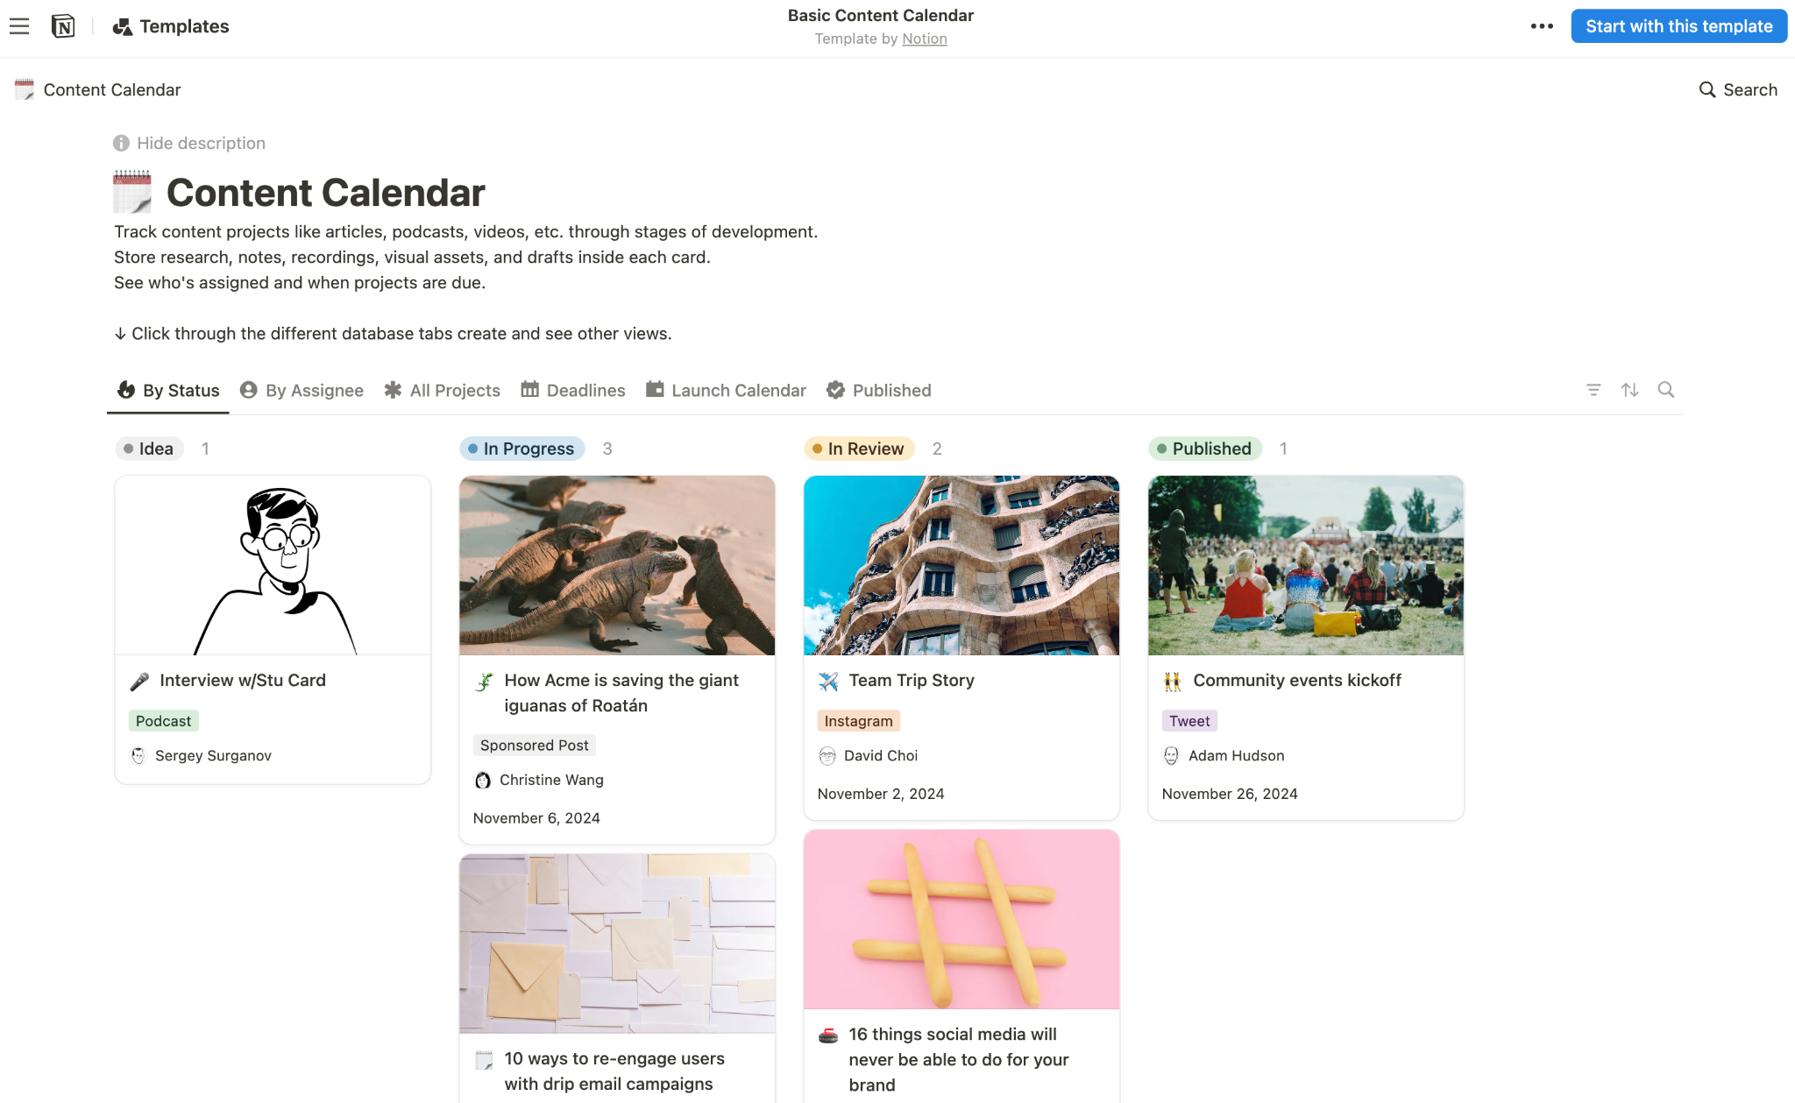
Kanban board to keep track of your content across its different stages.
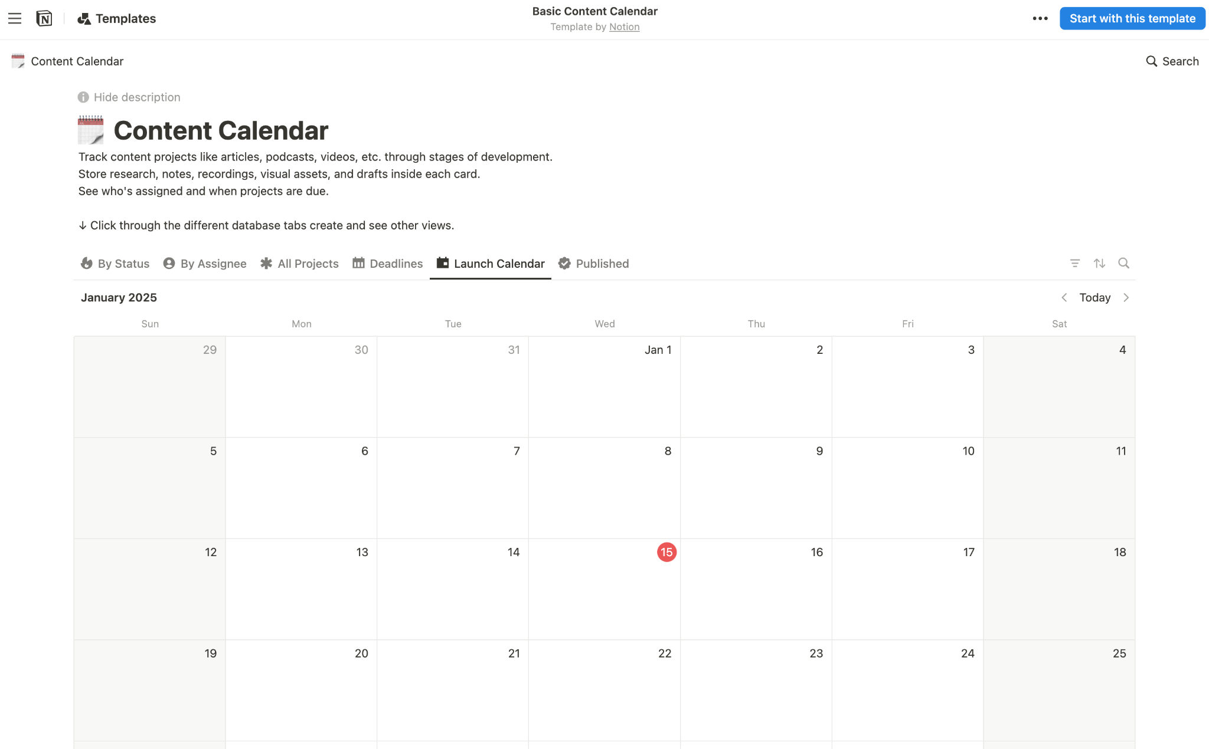
Set dates on each item in the Kanban to see it appear on the calendar. Drag to move it around!

Writing is Clear Thinking 🧘
"Clear writing means clear thinking. You don't know what you know until you try to express it." - Michael Seidman
The core of content creation isn't about fancy editing or perfect delivery - it's about clearly communicating your ideas, experiences, and knowledge. Writing is the foundation of all content, whether it's a YouTube script, LinkedIn post, or thread. Your ability to clearly articulate ideas will determine your success more than any other factor.

The Writing Environment 🍃
Creating focused time and space for writing isn't optional - it's essential. You need to treat your writing blocks as sacred time, just as you would an important client meeting. A proper writing environment includes:
- Quiet, isolated space with no interruptions
- All notifications turned off
- No background music or ambient distractions
- Single focus - just you and your writing tool
- 2-4 hour dedicated time blocks
Don't underestimate the importance of this setup. Many creators try to write while multitasking or surrounded by distractions, then wonder why their content isn't resonating. Great content comes from clear thinking, and clear thinking requires deep focus.

The Writing Process 📝
- Start with a brain dump
- Step away (ideally overnight)
- Return to write a proper first draft
- Step away again
- Write your final version
Start with a brain dump. Don't aim for perfection - just get all your ideas, research, and experiences onto the page. Use your Notion workspace to collect key points, relevant examples from your work, research data, and potential hooks. This messy first draft is crucial - it's where you discover what you really think about the topic.
The magic happens in the refinement phase. Step away from your first draft and return with fresh eyes. This is where you'll reshape and refine your ideas, focusing on making complex concepts simple and removing anything that doesn't serve your core message. Keep polishing until it flows naturally and your key points shine through.

Learning from Others 🤝
Becoming a great writer means being a constant student. Pay attention to content that captures and holds your attention. When you find yourself watching a video to the end or reading an entire thread, analyze why. Save these examples and study:
- Hook structures that grab attention
- Transition techniques between points
- Evidence presentation methods
- Call-to-action approaches

Essential Writing Tools 🖊️
Modern AI tools can significantly enhance your writing process:
- Claude.ai: Excellent for brainstorming ideas and refining your drafts. It can help you think through arguments and find clearer ways to express complex ideas.
- Perplexity.ai: Perfect for quick research validation and finding supporting evidence for your points. The pro version gives you deeper research capabilities.
- Notion: Your central workspace for organizing thoughts, drafts, scripts and content scheduling. I’ve provided a template to get you started earlier in this doc..

The Long Game 🌱
Success with content rarely comes quickly. Instead of chasing viral hits, focus on developing your craft as a writer and communicator. Each piece you create should be an opportunity to get better at expressing ideas clearly and connecting with your audience.
Remember that every great creator started somewhere. The key is to keep showing up, keep writing, and keep refining your process. The skill of clear communication compounds over time, and those who master it become the trusted voices in their space.

The Power of Hooks 🪝
The harsh reality of content creation in 2025: you have mere seconds to capture attention. Most people won't read past the first line or watch past the first 30 seconds of your content. This makes your opening - your hook - the most crucial element of any piece of content.

The Proof-Promise-Plan Method 💰
Alex Hormozi's proven framework for hooks breaks down into three essential elements:
- Proof: Lead with immediate credibility "Last month, we helped a local builder save 15 hours per week on paperwork using AI..."
- Promise: Clear value proposition "In this video, I'll show you the exact system we used, starting with free tools..."
- Plan: Outline the journey "First, we'll look at the current bottlenecks, then I'll show you the three tools that changed everything..."
This framework works because it immediately answers the viewer's subconscious question: "Why should I listen to you?"
Here's an example for construction content:
"Last month, we helped a local builder save 15 hours per week on paperwork using AI. In this video, I'll show you the exact system we used, starting with the free tools you can implement today. We'll begin with the biggest time-wasters in construction admin, then walk through each automation step-by-step."
The key is to front-load your best material. Don't save your strongest points for later - your audience needs to know within seconds that this content is worth their time. Study hooks that grab your attention and practice writing them daily. They're the gateway to getting your valuable content seen.
Great Video on Content Strategy:
Alex Hormozi Reveals His Content Strategy for Entrepreneurs (2025 Update)

Part 3: The Filming Process 🎬
For video content, there is an added step of needing to film. This section breaks down the best approach for beginners.

Starting Your Video Journey 🏁
One of the biggest barriers to video content is the belief that you need expensive equipment to start. The truth is, your phone is enough to begin creating valuable content.
The success of your videos will be determined 80-90% by the content of your video and having the right video concept, title and thumbnail that attracts viewers in, not by how high quality your video production is (lighting, camera quality etc).

Basic Setup for Beginners 🤳
Here's all you need to start:
- Your smartphone (any recent model)
- Basic phone stand (~$30 on Amazon)
- Good natural lighting
That's it. Don't let equipment become an excuse for not starting.

Lighting for Beginners 🔦
Natural lighting is your best friend when starting out. Film near a window, but avoid direct sunlight that can create harsh shadows. Cloudy days provide perfect diffused lighting naturally. If you're dealing with harsh sunlight, use sheer curtains to soften it. The key is ensuring your face is evenly lit without harsh shadows or bright spots.

Recording Process 📹
Most video creators start with a fully scripted approach, but this often leads to stiff, unnatural delivery. Instead, I recommend a hybrid approach:
- For your hook (first 30 seconds), write and memorize a precise script. This opening needs to be perfect since it determines whether viewers stay or leave. Record this section line by line if needed, and stitch it together in editing.
- For the main content, work from an outline rather than a full script. Write down your key points, examples, and any specific data you need to reference, but deliver them naturally as if you're explaining to a friend. This creates more authentic, engaging content. You'll develop your own style over time, but starting with this outline approach helps you avoid the robotic delivery that often comes with full scripts.

Your outline might look something like this:
- Hook (scripted, proof promise plan method)
- Main problem introduction
- Key points (3-4 max)
- Examples/evidence
- Solution walkthrough
- Call to action
Remember to keep your energy up throughout recording. If you stumble, simply pause and start that section again - you can clean it up in editing. The goal is natural, conversational delivery while ensuring you cover all your important points.
Most beginners make these critical mistakes that are easy to avoid:
- Speaking too quickly (slower than feels natural usually works better)
- Poor audio (film in a quiet room, close to phone)
- Inconsistent eye contact with camera
- Cluttered or distracting background
- WAY TOO LONG INTROS. GET TO THE POINT!

When to Upgrade 🛠️
After creating 10-20 videos and establishing a consistent process, you might want to invest in better equipment. Here's what a professional starter setup looks like:
- Sony ZV-E10 Camera ($700): Excellent autofocus and video quality
- Shure MV7+ Microphone ($300): Professional audio quality
- Teleprompter with phone mount: Speeds up filming process
- Ring light: For consistent lighting in any conditions
- Professional tripod: For stable shots
Total investment: Around $1,200
Remember: This upgrade should come after you've proven your commitment to consistent content creation. Many successful creators started with just a phone and good lighting. Focus first on developing your on-camera presence, clear communication style, and consistent content schedule. The equipment can come later when it's clear that video is a key part of your marketing strategy.

Part 4: Editing Your Content ✂️
Editing is where good content becomes great. Whether you're creating written or video content, this stage is crucial for clarity and impact.

Written Content Editing 📄
The key to good editing is distance. Come back to your content the next day with fresh eyes. As Alex Hormozi explains in his excellent LinkedIn video on proofreading, you need to approach your content as a ruthless editor.
Here's the process:
- Let it rest overnight
- Read it aloud - hearing your words reveals awkward phrasing
- Remove unnecessary words
- Simplify complex language
- Break up long paragraphs
Use the Hemingway Editor (hemingwayapp.com) to help identify:
- Complex sentences
- Passive voice
- Unnecessary adverbs
- Simpler alternatives for complicated words
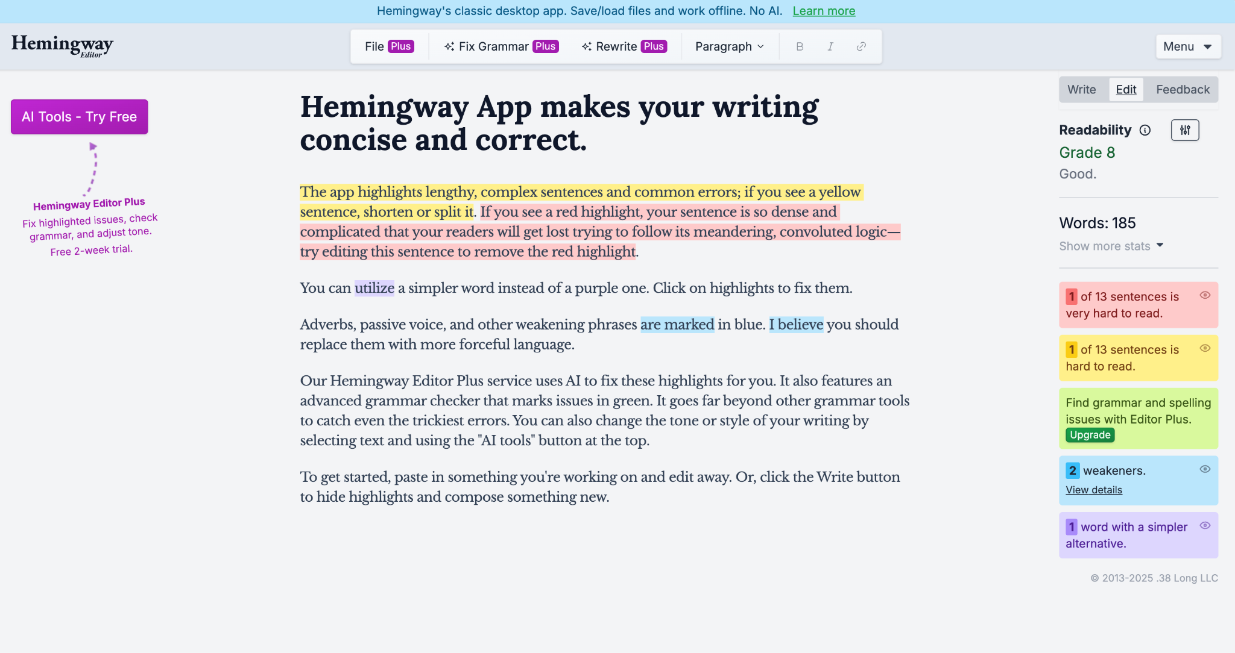
Remember: Clarity beats cleverness every time. Your goal is to communicate your ideas as simply and directly as possible.

Video Editing 🎞️
While video editing might seem daunting, it doesn't need to be complex or time-consuming. You have two main options:

Option 1: Outsource (Recommended)
Hiring a video editor is often worth the investment, allowing you to focus on creating content rather than technical editing. Find editors on Fiverr or Upwork who can:
- Cut together your footage
- Add basic text when needed
- Clean up audio
- Create simple transitions
Expect to pay $50-100 per video for basic editing. When hiring, look for editors who understand that simple, clean editing often works better than flashy effects.

Option 2: DIY Editing
If you're editing yourself, stick to the basics:
- Use iMovie (Mac) or OpenShot (Windows)
- Focus on clean cuts
- Avoid default text animations and transitions
- Keep it simple and professional
Whether outsourced or DIY, avoid common beginner mistakes like:
- Over-editing with fancy transitions
- Using dated text animations
- Adding background music that's too loud
- Over-complicating what could be simple
The goal of editing is to enhance your message, not distract from it. Clean, simple editing that focuses on clarity will serve you better than flashy effects.

Part 5: Publishing Your Content 📤

Getting Started with Publishing 🗒️
Early in your content journey, publishing should be straightforward - just focus on consistently posting to your chosen platform according to the schedule you've set (e.g., two videos per week for YouTube, or 3-4 posts per week for LinkedIn).

Platform-Specific Tools 🛠️
Each platform offers its own scheduling capabilities, but there are also specialized tools that can make publishing easier:
- Hypefury: Best for scheduling and automating X posts
- Taplio: Excellent for LinkedIn content management
- Instagram: Built-in scheduling through Creator Studio
- YouTube: Native scheduling through Studio

Timing Your Posts ⏳
Don't get caught up in perfect posting times, especially when starting out. Consistency matters more than timing, particularly on YouTube where content can be discovered months after publishing.

Jumpstarting Engagement ⚡️
The key to algorithmic success is showing platforms that your content resonates with the right audience. Here's how to give your content an initial boost:
For YouTube videos, direct relevant traffic to your new uploads. This helps YouTube understand who finds your content valuable. Without an email list, share your videos in relevant communities where your target audience hangs out - for example, if you create content for builders, share in construction business groups (where allowed).
The same principle applies across platforms - more engagement time equals more reach. Find pockets of your ideal audience and share your content with them. Their engagement signals to algorithms who else might find your content valuable.

Advanced Publishing (For Later) 🚀
Once you've built a following across multiple platforms, you can create a coordinated publishing strategy where one main piece of content (like a YouTube video) gets promoted across all your channels and to your email list. But that comes later - for now, focus on mastering one platform and building genuine engagement there.
Remember: Consistency on one platform beats scattered effort across many. Stick to your chosen platform and schedule until you've established a strong foundation.

Part 6: Analyzing Your Content Performance 📊

The Power of Review 🔍
One of the most overlooked steps in content creation is systematic performance analysis. While many creators constantly push out new content, the real growth comes from understanding what's already working and doing more of it.
As the saying goes, "We need to be reminded more than we need to be told." Don't be afraid to revisit topics that performed well - not everyone saw your first piece on the subject, and those who did might benefit from hearing it presented differently.

Monthly Content Review 📆
Set aside time each month to analyze your content performance. Look for:
- Which topics generated the most engagement
- Which hooks performed best
- Common themes in successful content
Use these insights to inform your next month's content calendar. This isn't about copying yourself - it's about understanding what value your audience most wants from you.

Finding Your Lane 🚴
My own journey illustrates this principle perfectly. Early in my content creation, I noticed that AI development tutorials for businesses - particularly about building custom knowledge chatbots and AI systems - consistently outperformed other content. Instead of trying different topics, I doubled down on this niche. This focus not only accelerated my channel's growth but established my expertise in this specific area.

Metrics That Matter 📈
Focus on what really matters:
- Clicks on your links (I use https://bl.ink/ not Bitly)
- Newsletter signups through lead magnets
- Bookings made directly through your website
Instead of vanity metrics:
- Views
- Subscribers
- Likes
These deeper metrics tell you whether you're building a real connection with your audience, not just getting passing attention.

The Conversion Process: Converting Viewers into Meetings 🎯
Let's break down how to turn content viewers into actual leads. We covered the content creation process earlier - now it's time to focus on what happens after you post.
Remember our conversion steps:
- Post: Publishing valuable content
- Capture: Converting viewers into contacts
- Nurture: Building trust through email
- Convert: Making strategic offers to your audience

Why Capturing Contact Details Matters 📲
One of the most important concepts in digital marketing is understanding the difference between "rented" and "owned" audiences. When you post on platforms like YouTube, LinkedIn, or X, you're building a rented audience. These platforms can change their algorithms, suspend accounts, or lose popularity - taking your audience with them.
An owned audience is one you can contact directly, typically through email. This is why capturing contact details is crucial - it gives you a direct line of communication that isn't dependent on any platform's algorithms or rules.

The Capture Strategy: Lead Magnets 🎣
Since we've covered the posting process, let's focus on capturing contact details through lead magnets. A lead magnet is a valuable resource you offer in exchange for someone's email address. The key is that your lead magnets should be natural extensions of your content.
For example:
- If your video shows how to build a customer service chatbot, offer the template you used
- If you're explaining an automation process, provide a detailed workflow PDF
- If you're sharing AI tools, offer a comparison spreadsheet

Types of Lead Magnets for AI Automation Agencies 🧲
- Process templates and workflows
- AI tool comparison guides
- Implementation checklists
- ROI calculators
- Step-by-step tutorials/guides
- Access to private training videos
- Automation scripts and templates
- Case study deep-dives

Setting Up Your Lead Magnet System 🧲
We'll be using ConvertKit to handle the technical side of lead magnet delivery. It's simple to set up and provides everything you need to capture emails and automatically deliver your lead magnets.
Basic Setup Process:
- Create your lead magnet (PDF, template, etc.)
- Set up a ConvertKit form that collects first name and email
- Configure the automatic delivery email with your download link
- Create a simple landing page in ConvertKit (if needed)
- Link to your landing page in your content

Lead Magnet Best Practices 🏅
- Keep it closely related to your content
- Keep it simple but valuable
- Focus on solving one specific problem
- Make sure it leads naturally to your paid services

Technical Implementation ⚙️
Setting Up Your Lead Magnet Delivery: You'll need a ConvertKit account to set up your lead magnet delivery system. Watch these tutorials to learn how to set up a ConvertKit landing page form that automatically sends an email with your download link and confirms subscription:
- Complete ConvertKit Tutorial for Beginners
- ConvertKit Landing Page Tutorial 2023 (Unlimited Free Landing Pages)
Important: When setting up your landing page, make sure to use the "incentive email" feature shown in these videos - this is the ideal way to deliver lead magnets.
These tutorials will walk you through everything you need to know to get your lead magnet delivery system up and running quickly.
Remember: The goal is to provide additional value that makes sense in the context of your content. Don't just create lead magnets for the sake of having them - they should be natural extensions of the value you're already providing in your content.
In the next section, we'll cover how to nurture these new contacts through email…

Nurturing Your List: Building Trust Through Consistent Value 💎
The nurture phase is critical to converting leads into clients. This is where you build a relationship with your email list through consistent, valuable communication.

What is Nurturing? 💖
Nurturing means regularly providing value to your email list through helpful content and insights. For AI automation agencies, this means keeping business owners informed and educated about AI opportunities for their business.
Examples of valuable nurture content:
- Client case studies showing real results
- Interesting AI tools or developments you've discovered
- Templates and resources they can use immediately
- Quick AI implementation tips
- Industry-specific AI use cases
- Behind-the-scenes looks at your client work

Why Nurturing Matters ✅
This process is powerful for several reasons:
- Your list grows over time as more content brings in new subscribers
- The same effort reaches an increasingly larger audience
- You stay "top of mind" when businesses are ready to implement AI
- You build trust and authority through consistent value
- You create multiple opportunities for conversion
Think of it this way: A business owner might not need AI automation today, but when they do, you want to be the first person they think of. Regular nurturing ensures you're there throughout their decision journey.

Implementation Plan ⚙️
Here's how to get started:
- Add Emails to Your Content Calendar
  - You need to come up with ideas for emails just like your content ideas. Add them to an idea bank for your emails (get another copy of the template provided earlier)
  - Schedule your emails a few weeks out so you aren’t leaving it to the last minute
  - Experiment with different types of valuable content
- Write Weekly Emails
  - In your writing blocks write at least one value-packed email per week
  - Start even if your list is tiny (less than 100 people)
- Technical Setup
  - Watch this tutorial to learn how to send broadcasts to your list using Kit (formerly ConvertKit): How to Send Broadcast Emails in ConvertKit
Remember: The size of your list doesn't matter when you're starting - what matters is building the habit of consistent communication. Your list will grow over time as you continue creating content and capturing emails through lead magnets.
Start this process now, even if you only have 10 subscribers. The compound effect of consistent nurturing will build a valuable asset for your agency over time.

Advanced Strategy: Welcome Sequences 💌
While regular broadcasts are your main nurture tool, you can supercharge your conversion rates with an automated welcome sequence. This is a series of pre-written emails that automatically nurture new subscribers right after they download your lead magnet.

Why Welcome Sequences Work ✅
Rather than just dropping new subscribers into your regular broadcast list, a welcome sequence lets you:
- Properly introduce yourself and your expertise
- Share your most compelling case studies
- Tell your story in a deliberate way
- Build authority through structured content
- Make a perfectly timed offer

Example Welcome Sequence 🔎
- Welcome + Lead Magnet Delivery
- Your Story + AI Experience
- Client Case Study #1
- Free Mini-Course on AI Implementation
- Client Case Study #2
- Your Framework/Methodology
- Special Offer (Strategy Session, Audit, etc.)
After completing this sequence, subscribers automatically join your regular broadcast list, where they'll continue receiving your weekly value emails.

Implementation
Watch this tutorial to learn how to set up your welcome sequence in Kit (formerly ConvertKit): How to Deliver Your Lead Magnet Freebie in ConvertKit + Welcome Sequence
The visual automation feature makes it easy to:
- Create your email sequence
- Connect it to your lead magnet form
- Automatically move subscribers to your main list
- Track performance
Pro Tip: Test different sequence lengths and offers to find what works best for your audience. Some may convert after 3 emails, others might need 10.
Remember: The key is providing massive value before making any offers. Use this automated sequence to demonstrate your expertise and build trust systematically.

Making Offers That Convert 💸
The final stage of your content funnel is converting your nurtured leads into clients. Let's break down how to master the art of making offers to your list without burning them out.

The Give-to-Ask Ratio ⚖️
Alex Hormozi, in "$100M Leads," points to a well-studied marketing principle: the give-to-ask ratio. Television uses roughly a 3.5:1 ratio (47 minutes of content to 13 minutes of ads), while Facebook aims for 4:1 (four content posts for every ad).
For your email list, this translates to:
- 80% value-focused emails
- 20% offer-focused emails

Types of Offers 🤝
There are two main ways to present offers to your list:

Soft CTAs
These are subtle offers woven into value-focused emails:
- PS statements ("PS: If you're ready to implement this in your business, I have 2 consultation slots open next week")
- Natural transitions ("Speaking of automation ROI, we're currently offering free AI audits...")
- Resource mentions ("We've built systems like this for several clients...")

Hard CTAs
These are dedicated promotional emails focused entirely on an offer:
- New client openings ("Taking on 3 new clients for February")
- Special packages ("Implementation + Training bundle")
- Limited time offers ("48-hour implementation package discount")
- Exclusive opportunities ("Early access to our new AI audit service")

Offer Types for AI Automation Agencies 🧾
- Book a Discovery Call: Your go-to will be offering a discovery call for them to start the AI implementation process with you for something specific or they may just want to chat.
- Free AI Automation Audits: A comprehensive review of a business's processes to identify automation opportunities. You'll analyze their workflows, spot inefficiencies, and deliver a report showing where AI could save time and money. This builds trust and naturally leads to implementation work.
- Limited Consulting Slots: Opening your calendar for a specific number of new clients, typically with some urgency ("3 spots available for February"). This is your standard service offering but positioned as limited availability to drive action.
- Special Service Packages: Bundled offerings that combine multiple services at a special rate. For example, "Implementation + 3 months of support" or "Chatbot build + staff training" packaged together at a promotional price.
- Early Access to New Offerings: Giving your list first access to new services or products before public release. This rewards list loyalty and creates exclusivity, like beta access to a new automation tool or first spots in a new done-for-you service.
- Workshops: Group or individual sessions where you educate your leads on AI and its benefits, weaknesses and use cases within the industry. These can be sold as standalone offerings or used as add-ons to larger packages.
- Strategy Sessions: Focused consulting calls where you map out an AI implementation plan for their business. Usually 60-90 minutes, delivering a clear roadmap they can either implement themselves or hire you to execute.
- Pilot Programs: Reduced-price initial projects where you implement one specific automation to demonstrate value. These are designed to convert into larger ongoing relationships once you prove ROI.

The Kennedy Checklist for Compelling Offers 📋
Based on Dan Kennedy's direct response marketing principles, every offer should include:
- Scarcity: Must have genuine limitations (time, quantity, or access). People are more motivated by potential loss than gain.
- Deadline: Clear deadlines with real consequences ("price increases after Friday"). Without deadlines, prospects default to "maybe later."
- Unique Mechanism: Your proprietary approach that sets you apart - could be your implementation process or framework.
- Risk Reversal: Strong guarantees that show confidence and remove buying friction. Make the terms clear and specific.
- Value Build-Up: Stack up all components and their values before revealing price. Value must be established before price can be justified.
- Reason Why: Every element needs logical reasoning - why this price, why this deadline, why these terms.
- Call to Action: Be explicitly clear about next steps. Detail exactly what happens after they respond.
- Social Proof: Use real results and testimonials to validate claims. Let satisfied clients tell your story.
Try to use as many of these as possible, especially for your hard CTAs in order to get results!

Implementation Strategy ♟️
- Value Emails (80%)
  - Include soft CTAs in every value email
  - Place them naturally within content or as PS statements
  - Keep them low-pressure and relevant
- Offer Emails (20%)
  - Limit hard CTAs to 1-2 times per month
  - Use scarcity honestly ("3 slots for February")
  - Make compelling, time-sensitive offers
  - Include clear next steps
Remember: The success of your offers depends on the quality of your nurture emails. Provide consistent value, and your list will be more receptive when you make asks.
The beauty of this system is that once it's running, you'll always have a way to fill your calendar when needed. A well-nurtured list becomes your most valuable business asset.

Summary & Action Points 🏗️
Let's recap the core system and outline exactly how to implement it.

The Content Machine: How It All Works Together ⚙️
At its core, this system combines two key processes:
- Your content creation engine consistently puts out valuable material that demonstrates your expertise. This could be LinkedIn posts about AI implementation case studies, YouTube videos breaking down automation strategies, or threads explaining technical concepts simply.
- Meanwhile, your conversion process moves people from just viewing your content to becoming real leads. You offer valuable downloads (lead magnets) in exchange for email addresses, then nurture those relationships through regular emails until they're ready to book a call.

Why Temperature Matters: The Three Stages 3️⃣
- Cold → Warm: Your content turns complete strangers into followers. They discover you through platforms like YouTube or LinkedIn, find value in what you share, and start following for more.
- Warm → Hot: Once they're following you, you can convert them to email subscribers using lead magnets - valuable resources they get in exchange for their email. This moves them from a "rented" platform to your owned email list.
- Hot → Client: Regular valuable emails keep you top of mind and build trust. When you make offers for calls, you're talking to people who already know and trust you.

Your Implementation Plan 📋

First 30 Days
- Pick your platform (YouTube, LinkedIn etc)
- Get a copy of [TEMPLATE] Idea Bank
- Try each of the ideation methods and fill out the idea bank with 30-50 ideas
  - Content Ideation Reflection Exercise 💡
  - Content Idea Generation Prompt
- Sign up for Notion and set up your content calendar on this template.
- Pick 8-10 ideas to bring from the bank into Notion and schedule them
- Set aside 2-4 hours on your personal calendar for writing (some of this time will need to be used for filming if you’re using a video platform), 2-3x per week
- In these deep work blocks, flesh out your content ideas and use the AI tools mentioned to help with research and writing.
- Start publishing 1-2 pieces of content weekly

Days 30-90
- Get setup up on ConvertKit as shown in this: Complete ConvertKit Tutorial for Beginners
- Create your first lead magnet and attach it to a landing page on ConvertKit
- Plug your lead magnet as a CTA in your content to start capturing emails
- Keep your publishing schedule consistent
- Send weekly valuable emails to your list and get familiar with with this process
- Once you’ve got a good stream of new newsletter subscribers coming in, build out your welcome series to try nurture them and sell as they come in the door with a special offer
- 1-2x per month make hard CTAs to drive sales and bookings on your calendar

Days 90+
- Rinse and repeat! Look at what performs well and what doesn’t. Do more of what does, less of what doesn’t…

The Reality Check 🚨
Your first content will feel awkward. Everyone's does. The key is pushing through those first 8-12 weeks when most people quit. By month 3-4, you'll have:
- A growing email list of engaged prospects
- A solid bank of content proving your expertise
- A streamlined creation process
- Predictable lead generation
The system works if you stay consistent. Commit to it, protect your content creation time, and focus on providing real value. That's how you build a reliable lead generation engine for your agency.

Still Struggling? 🤯
If you’re struggling with consistently generating leads for your AI Automation Agency, my AAA Accelerator program provides you step by step guides on building out your client acquisition systems and includes unlimited 1-on-1 coaching with our expert sales, outreach, personal branding, offer creation and development coaches.
If you’d like to learn more, you can book in a free consultation with one of my AI business strategists. We’re here to help you find the best path for you: https://aaaaccelerator.com/
Aside from that…
Go, get 'em.
Liam 💪🏼

